Task 2: Algorithms & Problem Solving (C++)
Overview
Implementation of fundamental algorithms to strengthen problem-solving skills and understand algorithm efficiency.
Objective
- Implement at least three algorithms such as Merge Sort, Binary Search, and Knapsack.
- Analyze the performance of different algorithms.
- Develop efficient solutions for computational problems.
- Understand the importance of algorithmic complexity.
- Improve logical thinking and programming skills.
Tools Used
- GCC/G++
- Makefile
- Linux/Windows Terminal
Algorithm / Design
- Merge Sort: Implemented using the divide-and-conquer approach. The array is recursively divided into smaller subarrays and merged in sorted order.
- Binary Search: Implemented on a sorted array by repeatedly dividing the search space into halves until the target element is found.
- Knapsack Problem: Implemented using dynamic programming to determine the maximum achievable value within a given weight limit.
Complexity Analysis
Time Complexity
- Merge Sort: O(n log n)
- Binary Search: O(log n)
- Knapsack (Dynamic Programming): O(nW)

Space Complexity
- Merge Sort: O(n)
- Binary Search: O(1)
- Knapsack: O(nW)
Sample Input
8 4 6 2 9 1
Search Element: 6
Weights: 10 20 30
Values: 60 100 120
Capacity: 50
Sample Output
Sorted Array: 1 2 4 6 8 9
Element found at index 3
Maximum Knapsack Value: 220
Screenshots
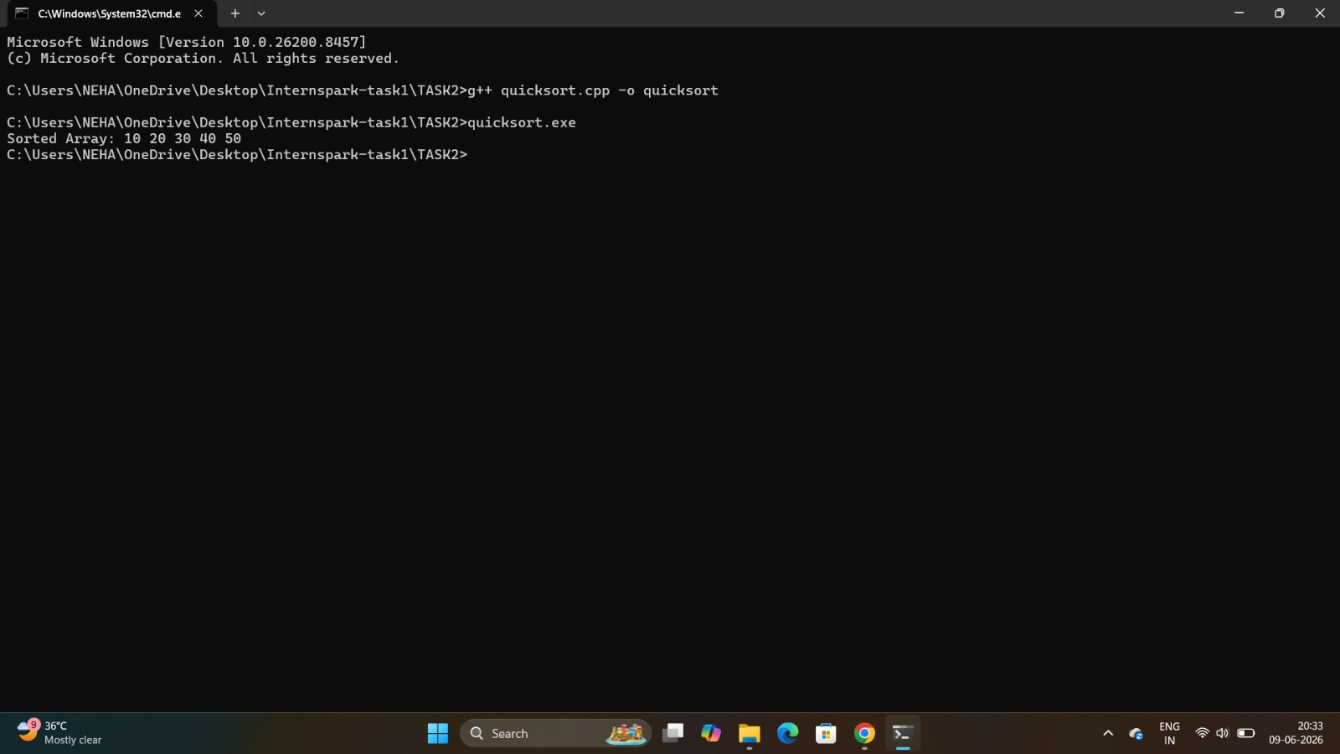
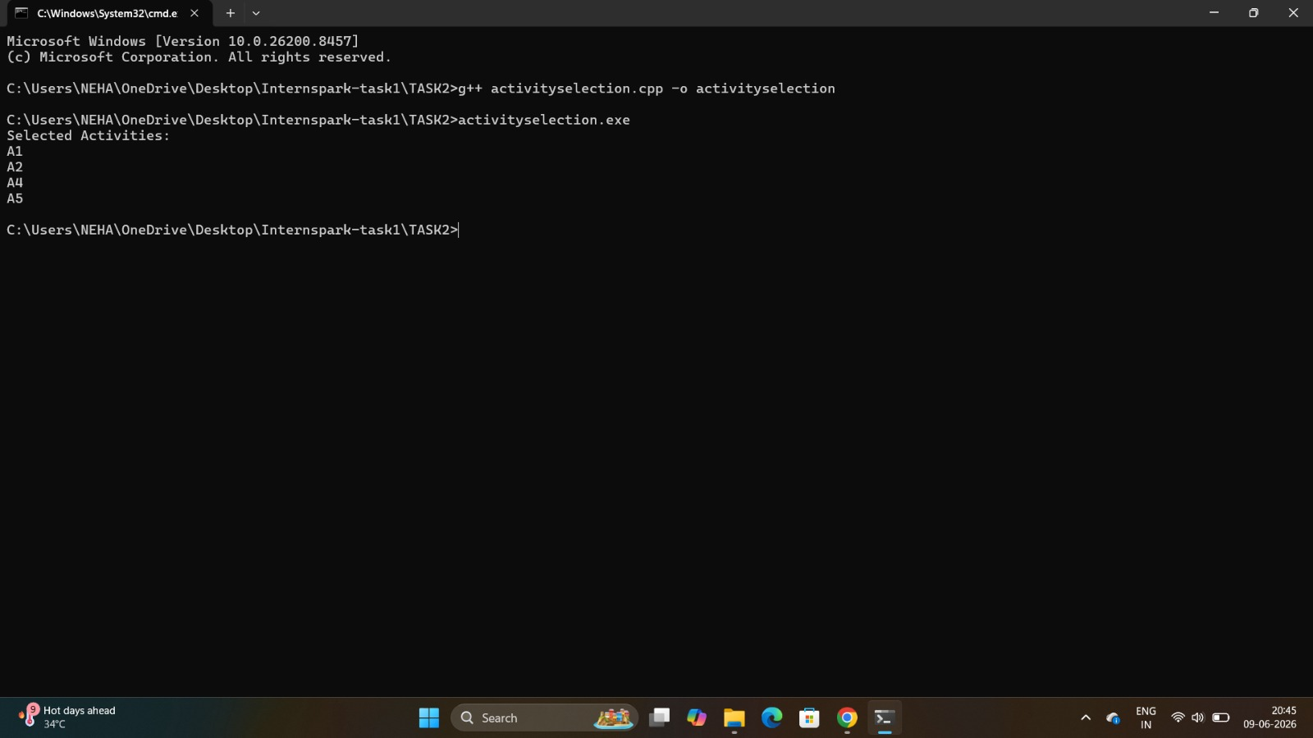
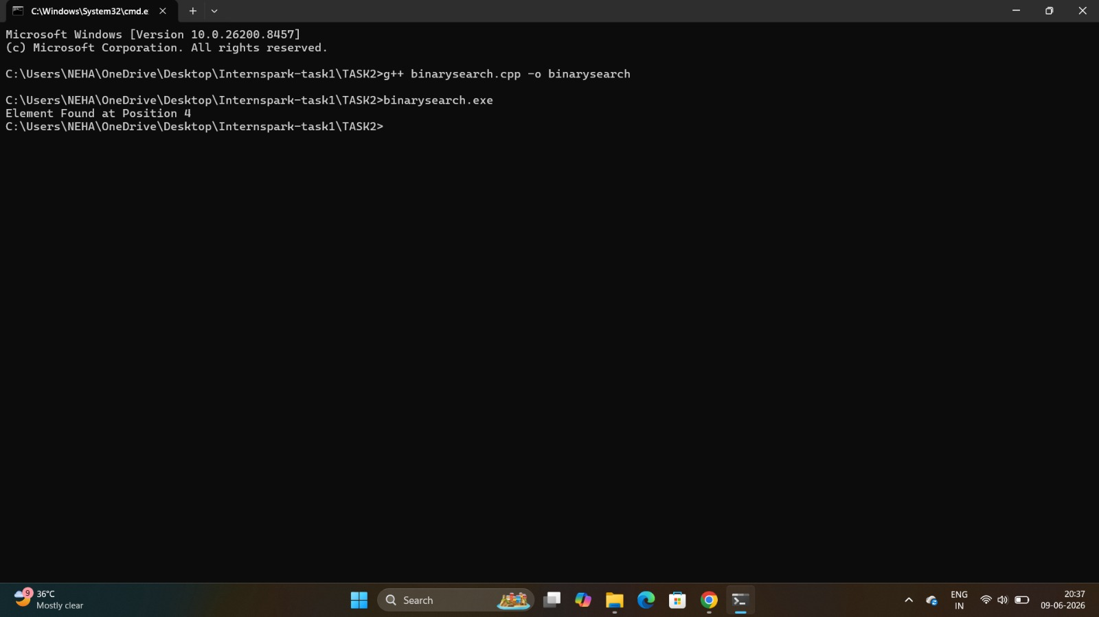
Conclusion
The algorithms were successfully implemented and tested. The task enhanced understanding of sorting, searching, dynamic programming, and algorithm efficiency analysis

